# Media Analysis - ‘I am not here to take your job,’ ChatGPT tells Frankly Speaking host _Updated 20 March 2023

## Short Summary

The text you provided offers an insightful overview of current discussions around AI, specifically focusing on ChatGPT s role and potential impact.

## Summary

The provided text explores the evolving landscape of artificial intelligence (AI), particularly focusing on OpenAI's ChatGPT and its integration into various technologies. Here's an overview:  
  
### Key Points  
  
1. **ChatGPT's Capabilities:**  
 - **Language Generation:** Known for generating natural, human-like text responses.  
 - **Image Understanding:** Recent updates allow it to process both text and image inputs, enhancing its application scope.  
  
2. **Industry Impact:**  
 - AI technologies like ChatGPT are becoming integral in industries such as healthcare, education, and communication by aiding tasks ranging from translation services to information access.  
 - Major tech companies, including Microsoft, Google (Bard), Amazon, Baidu, and Meta, are investing heavily in AI technologies to stay competitive.  
  
3. **Future Developments:**  
 - Focus areas include enhancing the naturalness of language models, improving context awareness, and personalizing responses through integration with other data sources.  
 - These advancements aim to meet user needs more effectively while promoting innovation within AI research.  
  
4. **Ethical Considerations:**  
 - The dual potential of AI as a beneficial or detrimental force underlines the importance of ethical usage.  
 - Issues such as privacy, bias, and job displacement are significant concerns that require attention from developers, policymakers, and users to ensure responsible use.  
  
5. **Vision for Humanity:**  
 - ChatGPT emphasizes the role of human decision-making in determining AI's impact on society.  
 - The ultimate goal is leveraging AI technology to enhance global wellbeing and foster a better future.  
  
This comprehensive perspective highlights both the opportunities and challenges presented by advanced AI technologies, underscoring the necessity of collaborative efforts towards ethical and beneficial implementations.

## Question 1

When analyzing how the media frames discussions around technologies like ChatGPT, several recurring metaphors and themes often emerge:  
  
1. **Tool/Machine Metaphor**: ChatGPT is frequently described as a tool or machine. This metaphor emphasizes its functional utility while also subtly suggesting it lacks autonomy or consciousness.  
  
2. **Assistant/Helper**: Often framed as an assistant or helper, this metaphor highlights the supportive role of AI in enhancing productivity and efficiency across various tasks, from journalism to customer service.  
  
3. **Race Metaphor**: The "race" among tech giants like Microsoft, Google, and Amazon to develop superior AI technologies is a prevalent narrative. This metaphor underscores competition, innovation speed, and the quest for technological supremacy.  
  
4. **Evolutionary Leap**: ChatGPT's advancements are sometimes likened to an evolutionary leap, suggesting significant progress compared to previous iterations of AI technology. This metaphor implies rapid development and increasing capabilities.  
  
5. **Double-Edged Sword**: This metaphor captures the duality of AI’s potential benefits and risks. It underscores optimism about improvements in sectors like healthcare while expressing concerns about privacy, bias, and job displacement.  
  
6. **Harmless vs. Dangerous Weapon**: The portrayal of AI as a potentially harmful or benign weapon highlights debates on ethical use and regulation. This metaphor reflects broader societal fears and hopes regarding technology's impact on humanity.  
  
7. **Human-AI Collaboration**: This metaphor frames the relationship between humans and AI as collaborative, suggesting that human oversight is essential in maximizing benefits while mitigating risks.  
  
These metaphors collectively shape public perception by emphasizing specific aspects of AI’s capabilities, potential impacts, and ethical considerations. The framing influences how society envisions future interactions with technologies like ChatGPT and informs policy discussions surrounding their regulation and use.

## Question 2

The topic you've presented revolves around AI language models like ChatGPT, with particular attention to their capabilities, ethical considerations, integration into major technology platforms, and potential societal impacts. Here's a breakdown of perspectives and aspects that are widely covered or potentially overlooked:  
  
### Widely Covered Aspects  
  
1. **Technological Advancements**:   
 - Developments in AI language models, such as the transition from GPT-3 to GPT-4, highlighting improvements in accuracy, naturalness, and response sophistication.  
 - Integration of AI into major tech products (e.g., Microsoft's Bing search engine).  
  
2. **Applications**:  
 - Diverse applications of AI technology, including language translation, information access, and task assistance in various sectors like healthcare and education.  
  
3. **Ethical Considerations**:  
 - Discussion about the ethical use of AI, addressing concerns related to privacy, bias, and job displacement.  
 - The need for responsible and ethical management by developers, policymakers, and users.  
  
4. **Human-AI Collaboration**:  
 - Potential roles of AI as a tool rather than a replacement in traditional fields like journalism.  
 - The balance between human roles and AI assistance in various industries.  
  
5. **Economic Impact**:  
 - Investments by major corporations (e.g., Microsoft) in AI technology.  
 - Competitive dynamics among tech giants regarding AI advancements.  
  
### Potentially Overlooked Aspects  
  
1. **Long-term Societal Impacts**:  
 - Less focus on how continuous AI integration might reshape societal structures over decades, particularly in employment and human relationships.  
  
2. **Global Disparities**:  
 - The implications of AI technology on global inequality, including access disparities between developed and developing regions.  
  
3. **Regulatory Challenges**:  
 - Specific regulatory frameworks necessary to address the rapid advancements in AI technologies.  
 - International cooperation or conflict regarding AI governance standards.  
  
4. **Psychological Impacts**:  
 - How increasing interaction with sophisticated AI affects human psychology, trust, and interpersonal dynamics.  
  
5. **Cultural Variations**:  
 - Consideration of cultural differences in the acceptance and use of AI technology, and how these might influence global adoption patterns.  
  
6. **AI Misuse and Security Risks**:  
 - Detailed exploration of potential misuse scenarios (e.g., deepfakes, misinformation) and robust measures to mitigate such risks.  
 - Cybersecurity concerns specific to AI technologies.  
  
Addressing these overlooked aspects could provide a more comprehensive understanding of the implications of advancing AI technology on various facets of society.

## Question 3

The Arabic world is referenced in this article primarily through its mention of Arab News, a leading English-language newspaper based in Saudi Arabia, which interviewed ChatGPT about its capabilities and applications. Additionally, the article notes that Microsoft integrated ChatGPT into various products like Bing search engine and Edge browser, suggesting how AI tools could enhance communication across different cultures and backgrounds, including Arabic-speaking audiences.  
  
In terms of leveraging AI, the article does not provide specific examples of how the Arabic world is uniquely using or developing AI technologies beyond this context. However, by engaging with platforms like ChatGPT through reputable media outlets such as Arab News, there's an implication that the Arabic world is exploring and discussing the potential applications and impacts of AI technology.  
  
Thus, while direct involvement in AI development isn't detailed, the article suggests engagement and interest from the Arabic perspective in understanding and utilizing AI tools. If you're looking for specific initiatives or projects within the Arabic world related to AI beyond this context, they are not mentioned here.  
  
**Summary**: The role is largely about engaging with and discussing AI technologies through platforms like Arab News; specific initiatives leveraging AI by the Arabic world aren't detailed.

## Question 4

The final message emphasizes the dual potential of AI like ChatGPT as either beneficial or harmful, depending on human usage. It underscores the importance of responsible and ethical development and regulation by developers, policymakers, and users to ensure AI contributes positively to society. The focus is on leveraging AI for improvements in healthcare, education, and communication while addressing concerns such as privacy, bias, and job displacement.

## Sentiment

The sentiment is -4.0

## Entities

Arab News, Google, Bing, OpenAI, Microsoft, Jensen, Amazon, ChatGPT, Meta, Baidu, Sam Altman, AI, Edge, Katie Jensen, Bard, Frankly Speaking

## Highlights

#c885da: 29

#f9cd59: 20

#7cc867: 65

#fb5b89: 50

#69aff0: 7

## Wordcloud for #c885da Highlights

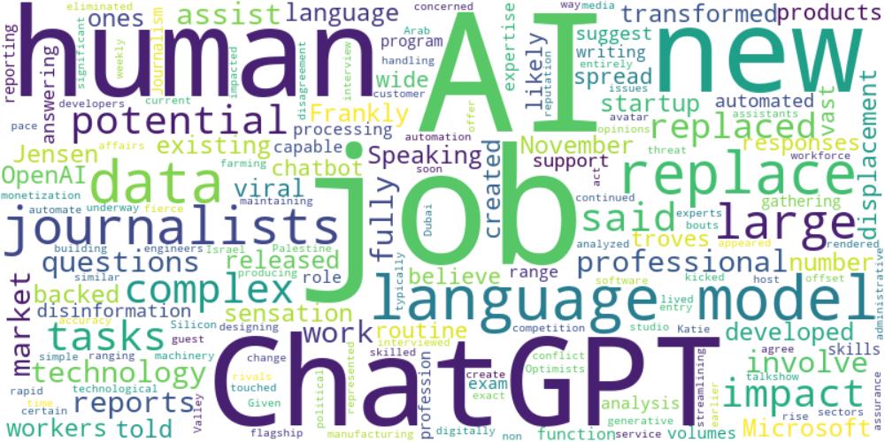

Top 10 words:

- AI: 18

- jobs: 10

- language: 10

- ChatGPT: 9

- human: 9

- job: 7

- data: 7

- replace: 7

- journalists: 7

- large: 6

## Wordcloud for #f9cd59 Highlights

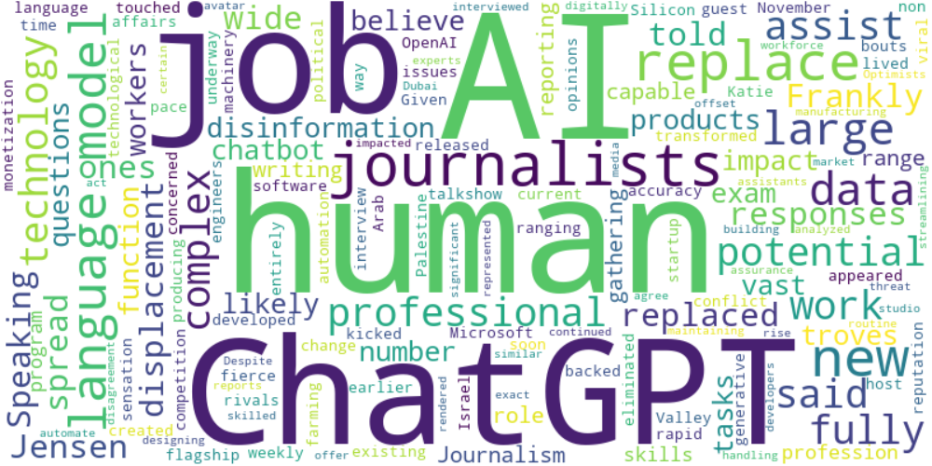

Top 10 words:

- AI: 10

- human: 9

- ChatGPT: 7

- journalists: 7

- language: 6

- replace: 6

- jobs: 4

- large: 4

- data: 4

- like: 3

## Wordcloud for #7cc867 Highlights

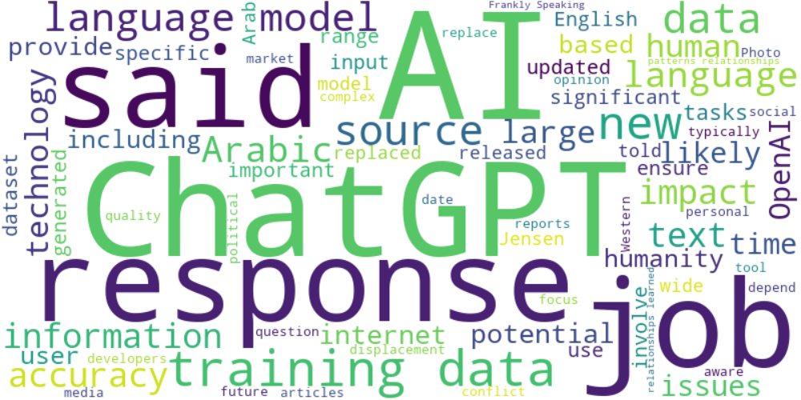

Top 10 words:

- AI: 27

- data: 24

- ChatGPT: 20

- language: 18

- training: 16

- responses: 14

- said: 14

- jobs: 9

- sources: 9

- new: 8

## Wordcloud for #fb5b89 Highlights

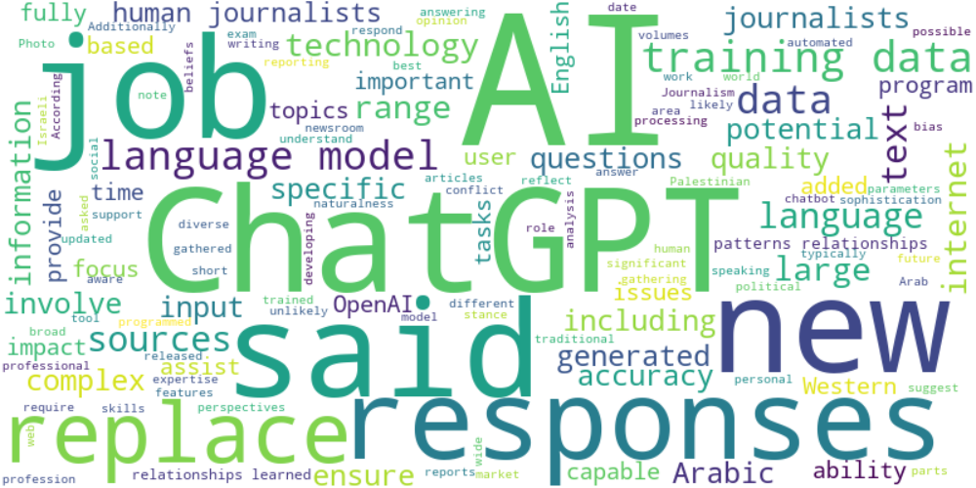

Top 10 words:

- AI: 22

- data: 17

- language: 14

- ChatGPT: 13

- said: 11

- responses: 10

- training: 10

- replace: 9

- journalists: 8

- jobs: 7

## Wordcloud for #69aff0 Highlights

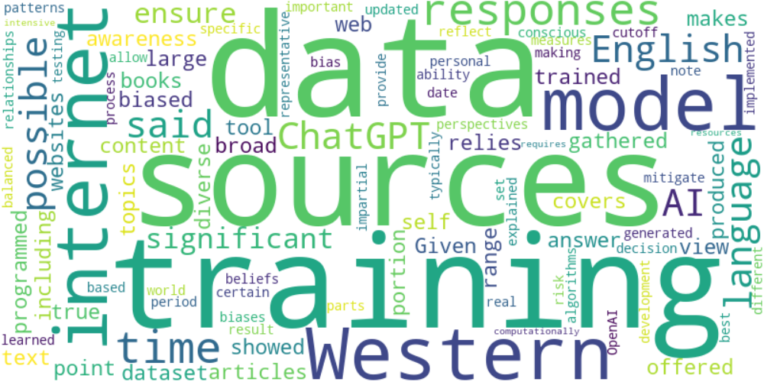

Top 10 words:

- data: 5

- sources: 4

- training: 4

- Western: 3

- internet: 3

- model: 3

- responses: 3

- time: 3

- English: 2

- possible: 2